
Accountants
They prepare and examine financial records. They also help with taxes and budgeting.
They work indoors at banks, accounting firms, agricultural/food companies, and business consulting firms.
They need a bachelor’s degree and often an accounting license.

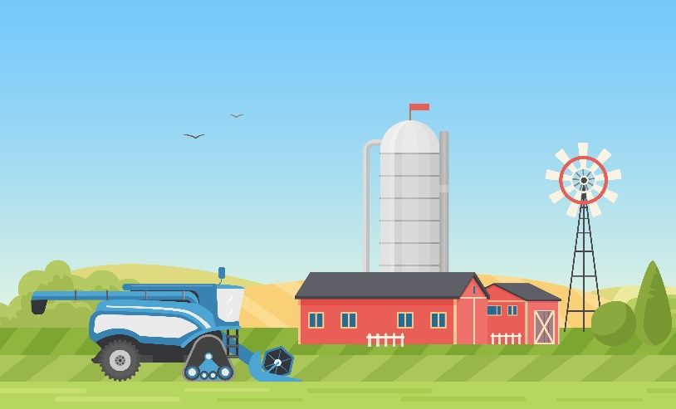
Agricultural Engineers
They design objects and processes to improve the equipment, buildings, and the environment of agriculture.
They work indoors and outdoors at engineering firms, government agencies, and agricultural equipment companies.
They need a bachelor's degree and sometimes an engineering license.

Agricultural Instructors
They teach students about agriculture, natural resources, and related STEM subjects.
They work indoors and outdoors at high schools, career-technical centers, community colleges, and universities.
They need a bachelor’s degree and a teaching license or graduate degree.

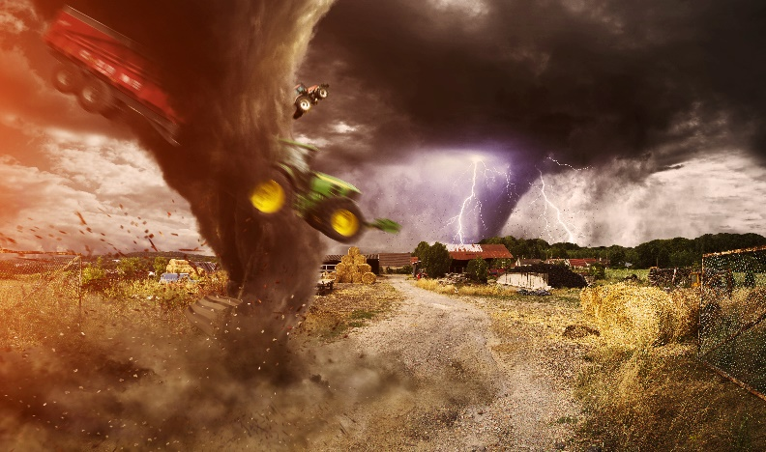
Agricultural Insurance Adjusters
They help with insurance claims by inspecting farm damage from weather and pests, then estimating the losses.
They work outdoors, travel often and are self-employed or a part of an insurance company or government agency.
They need a high school diploma and often an adjuster certificate or license.

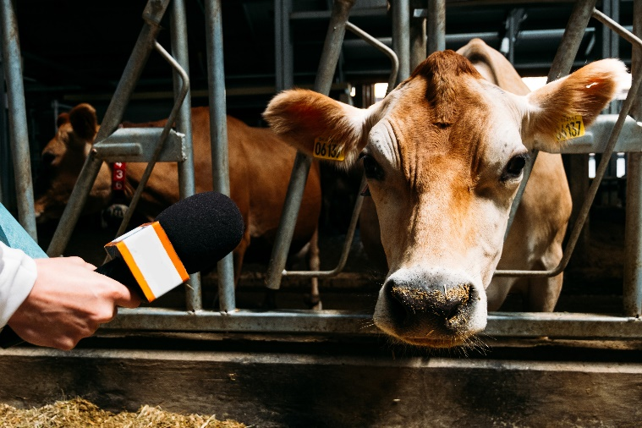
Agricultural Journalists
They gather and report agricultural news and communicate with the public about agricultural topics.
They are self-employed or part of a trade organization/media company. Work settings vary by job.
They need a bachelor’s degree.

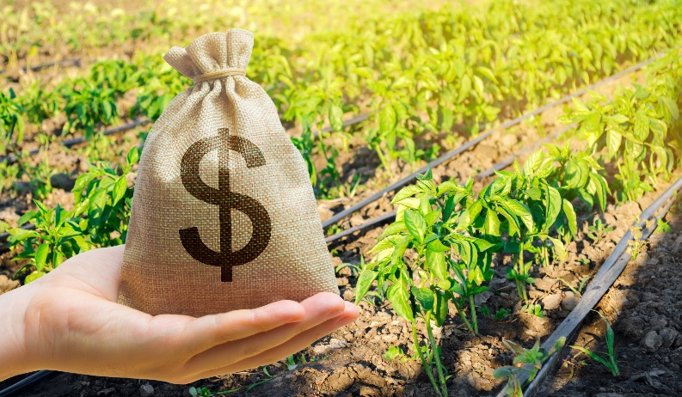
Agricultural Loan Officers
They lend money to farmers who are likely to maintain or expand the business and pay back the loan with interest.
They work indoors at banks and government agencies.
They need a bachelor’s degree.


Agricultural Marketers
They promote their company and its products and services to increase awareness and sales.
They work indoors at agricultural/food companies, and marketing firms.
They need a bachelor’s degree.

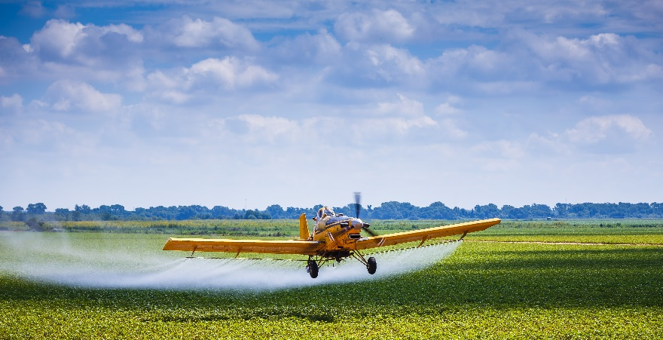
Agricultural Pilots
They fly planes to take photos of farmlands and to apply seeds or chemicals from the air.
They are part of cooperatives or agricultural aviation companies. They fly from sunrise to sunset during busy times.
They need a high school diploma, multiple licenses, and extensive training.

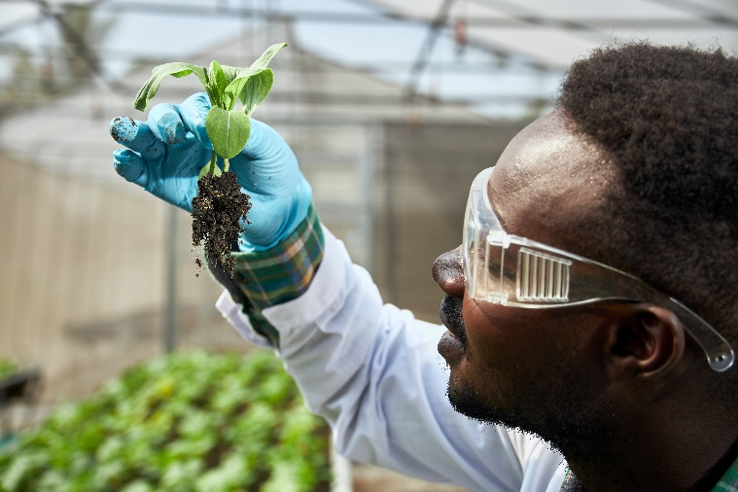
Agricultural Researchers
They conduct experiments on the genetics and management of crop plants and livestock animals for faster and better growth.
They work indoors and outdoors at universities, government agencies, and agricultural input companies.
They need a graduate degree in their area of expertise.
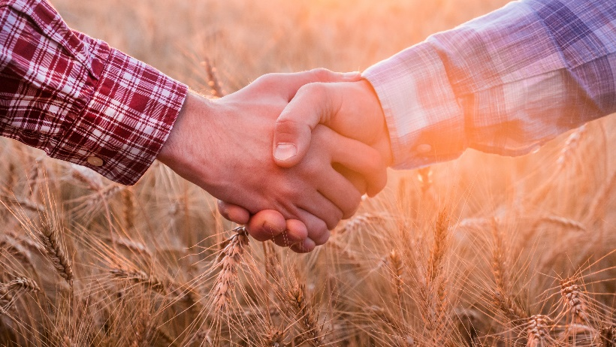
Agricultural Input Salesperson
They explain and sell products for raising crop plants and livestock animals, such as seeds, feed, chemicals, and farm equipment.
They are a part of manufacturers and retailers of agricultural inputs. Work settings vary by job.
They need a bachelor’s degree.

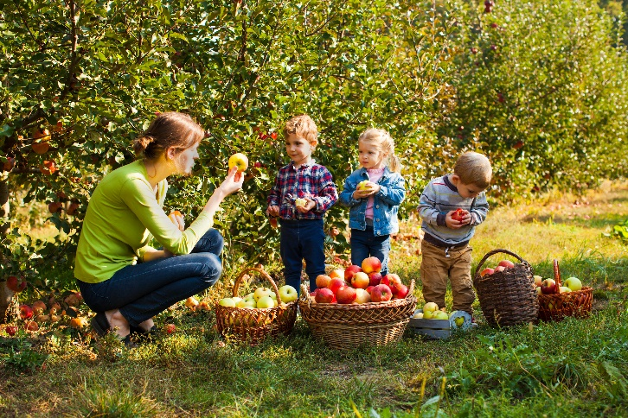
Agrotourism Educators
They teach visitors about agriculture and natural resources through recreational activities.
They work outdoors at farms, parks, museums, tour/outfitting agencies, and conservation organizations.
They need a high school diploma and sometimes a college degree.

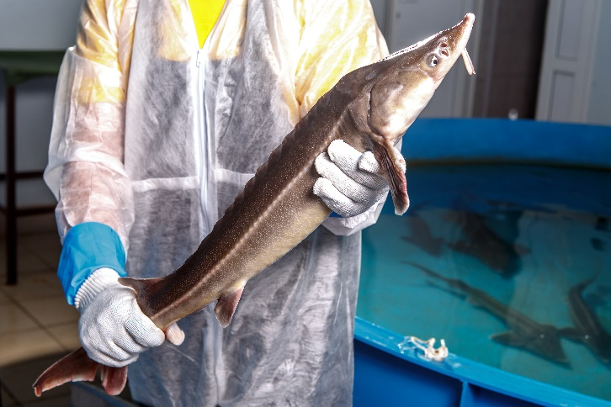
Aquaculturists
They lead the care of farmed/captured aquatic animals to breed, grow, and harvest these animals as intended.
They are a part of fish/shellfish farms, aquariums, and government agencies. Work settings vary by job.
They need a bachelor’s degree.

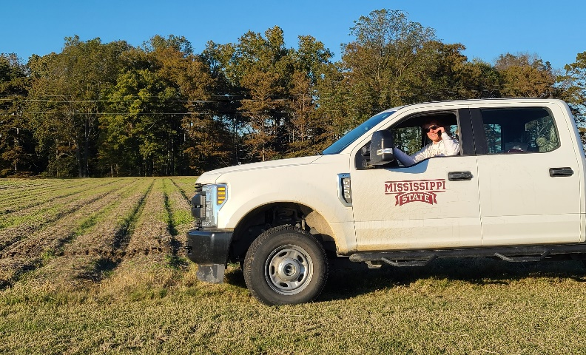
Cooperative Extension Agents
They connect people and share information to help the local community with agricultural and other needs.
They are based in county offices but may travel often to meet with clients and lead educational programs.
They need a bachelor’s degree and sometimes a graduate degree.

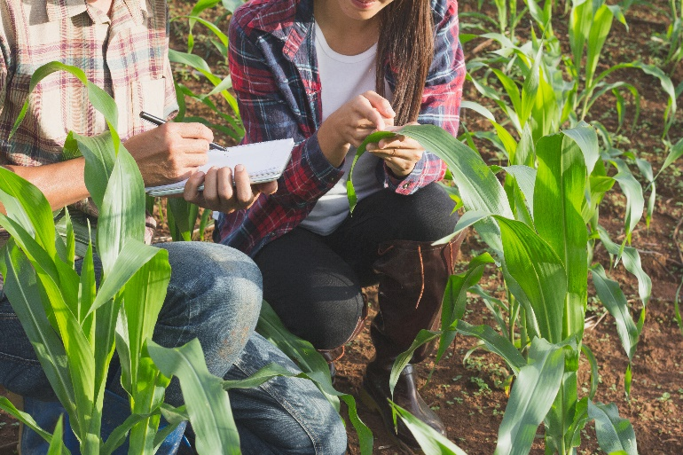
Crop Advisors
They check plants, soils, and pests regularly and advise farmers on how to best manage the crops.
They travel often and work outdoors at agricultural consulting firms and agricultural input companies.
They need a bachelor’s degree and often professional certification.

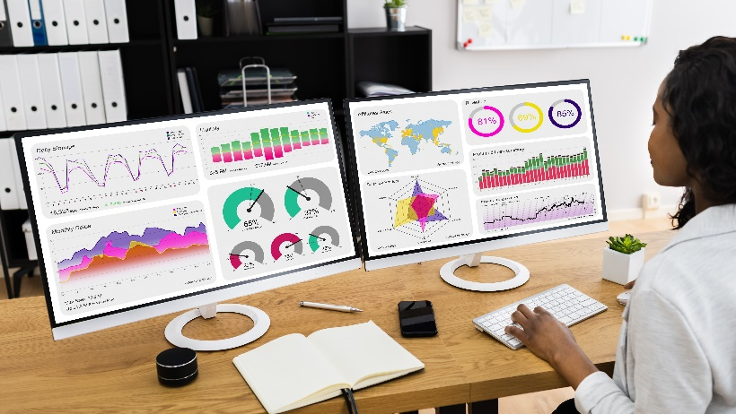
Data Analysts
They gather numbers, look for patterns, and make recommendations based on what they find out.
They work indoors at government agencies, business consulting firms, and agriculture/food and financial companies.
They need a bachelor’s degree.


Dietitians
They give eating advice and create meal plans that best fit the health condition and nutritional needs of their clients.
They work indoors at health care facilities, government agencies, and food processing/service companies.
They need a graduate degree and also extensive supervised practice in dietetics.

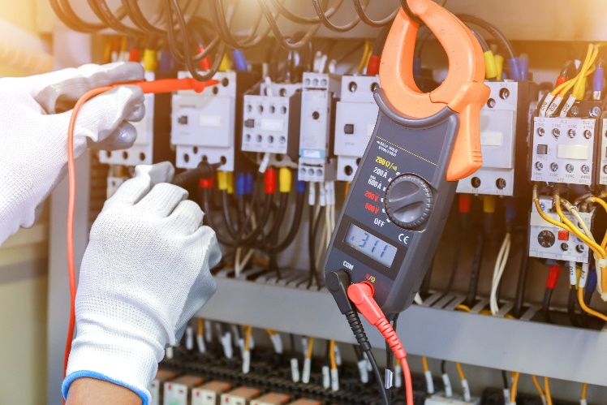
Electricians
They install and repair electrical systems so that these systems function properly, remain safe, and meet regulations.
They work indoors and outdoors at agricultural/food companies, and electrical contracting firms.
They need a high school diploma and often an apprenticeship and license.

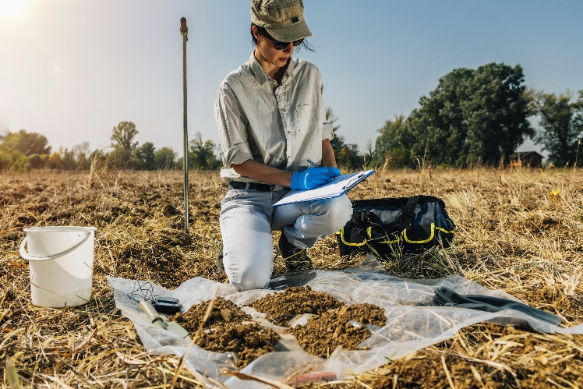
Environmental Technicians
They measure environmental quality and help make changes to protect or improve an environment/area.
They work indoors and outdoors at engineering firms, conservation organizations, and government agencies.
They need an associate degree.

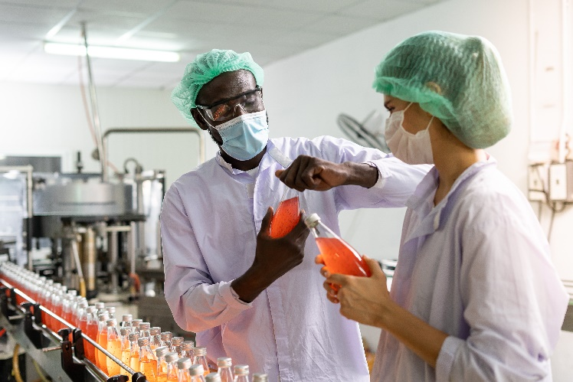
Food Processing Technicians
They perform various tasks necessary to turn plant and animal ingredients into food products.
They work indoors at food processing companies.
They need a high school diploma.

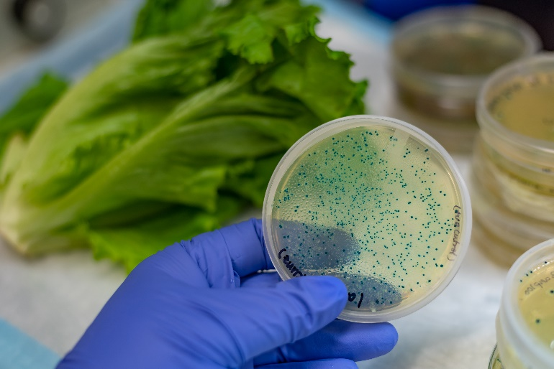
Food Safety Specialists
They ensure that a food product is safe to eat and that all company standards and government rules have been followed.
They work indoors at food processing companies and government agencies.
They need a bachelor’s degree and sometimes a graduate degree.

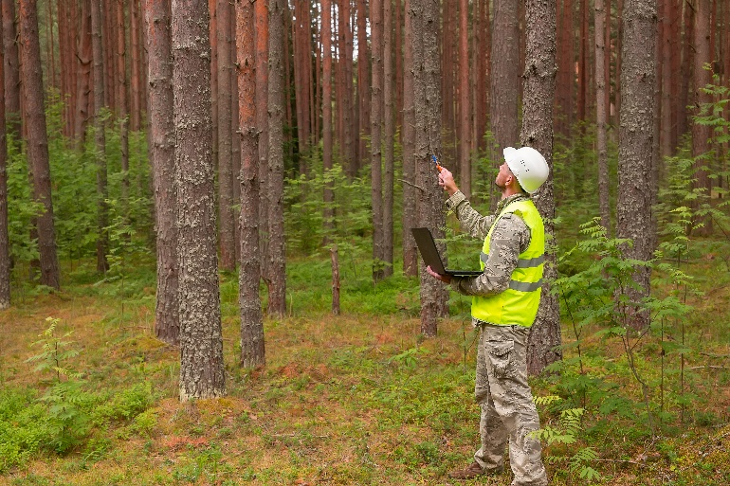
Foresters
They manage forests by assessing trees, advising landowners and directing replanting, harvesting, and burning.
They work outdoors at forestry companies and government agencies.
They need a bachelor’s degree and sometimes a certification or license.

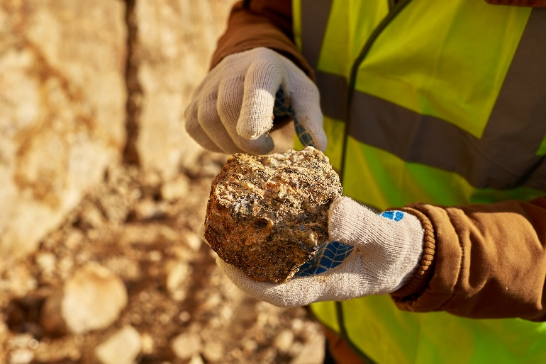
Geologists
They study the properties of rocks and the oil, gas, water, and minerals that rocks can contain.
They work indoors and outdoors in oil and gas, mining, and drilling firms, and at government agencies.
They need a bachelor’s degree and sometimes a graduate degree.

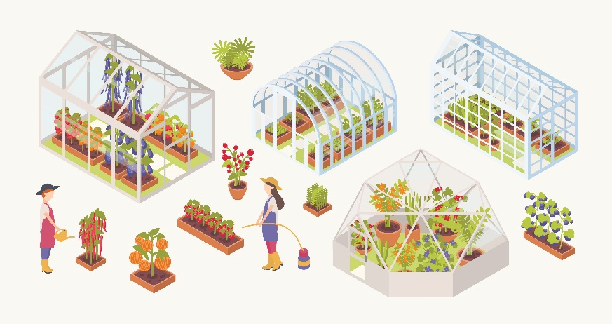
Greenhouse Managers
They lead the care of greenhouse plants and facilities so that plants are grown, harvested, and multiplied as intended.
They work at vegetable/fruit farms, plant nurseries, seed companies, and agricultural research centers.
They need a high school diploma.

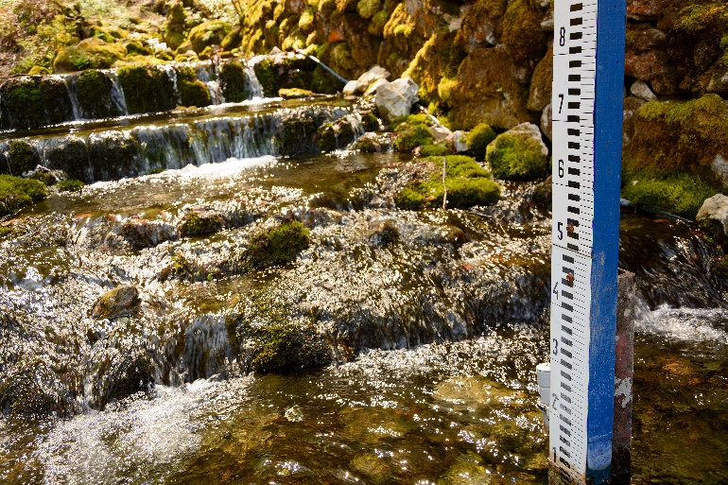
Hydrologists
They study the movement and properties of water and the related causes and effects.
They work indoors and outdoors at government agencies, engineering firms, and conservation organizations.
They need a bachelor’s degree and sometimes a graduate degree.


Information Technology (IT) Programmers/Developers
They design, build, maintain, and improve websites and software for people and businesses to use.
They work indoors at public or private employers that own the websites and software or at IT contracting firms.
They need a bachelor’s degree.

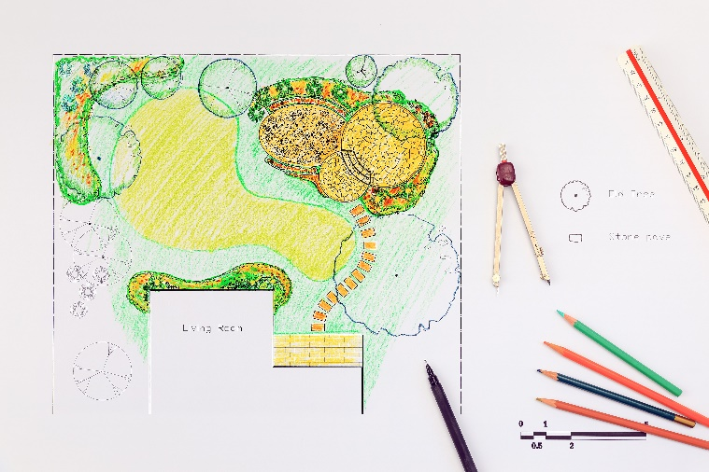
Landscape Architects
They plan and design beautiful and functional landscapes for various public and private spaces.
They work indoors and outdoors at landscape architecture firms and engineering firms.
They need an accredited bachelor’s degree and license in landscape architecture.

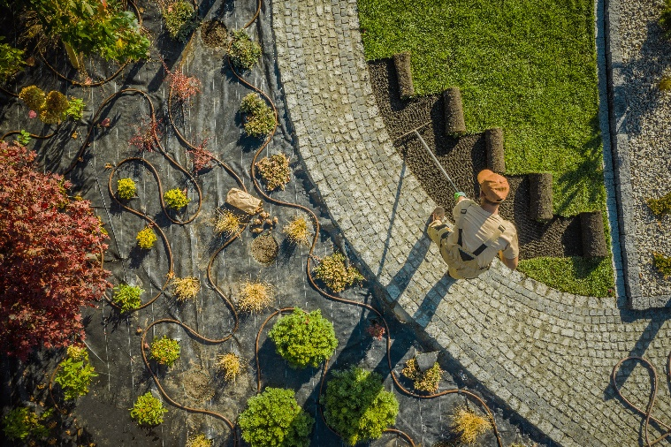
Landscape Technicians
They install and maintain plants, hard features, and irrigation systems to create beautiful and functional landscapes.
They work outdoors at landscaping contracting firms and sports/recreation facilities.
They need a high school diploma and sometimes landscaping certifications.


Machinists
They cut metals to make precise custom parts and tools by drilling, turning, milling, and grinding.
They work indoors at agricultural equipment, food processing, mining, oil and gas, and construction companies.
They need a high school diploma and sometimes machinist credentials.

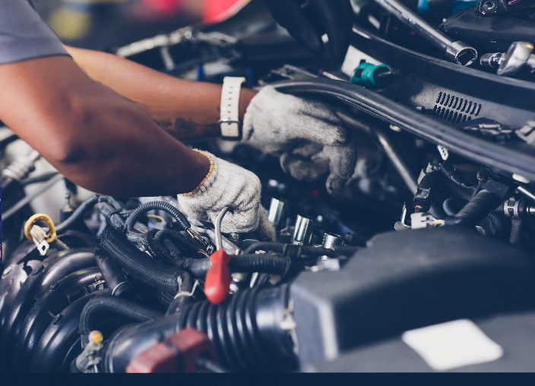
Mechanics
They inspect, repair, and maintain vehicles and heavy machinery.
They work indoors and outdoors at repair shops and at agricultural equipment, food processing, and construction companies.
They need a high school diploma and sometimes mechanic certifications.


Packaging Designers
They design food packaging that is attractive to customers, effective for storage, and reasonable in cost.
They work indoors at food processing companies and design agencies.
They need a bachelor’s degree.

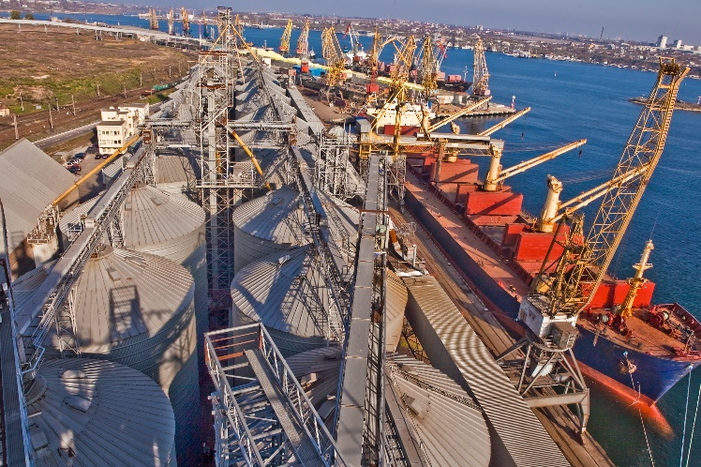
Procurement/Merchandising Agents
They help with the buying and selling of agricultural/food products each step of the way from farms to customers.
They work indoors at cooperatives, trading companies, food processing companies, distributors, and retailers.
They need a bachelor’s degree.


Product Development Technologists
They apply knowledge of food processing and customer preferences to create a new or improved food product.
They work indoors at food processing companies.
They need bachelor’s degree and sometimes a graduate degree.


Sensory Scientists
They find out what makes a food delicious or not and why—in terms of taste, smell, sight, touch, and sound.
They work indoors at food processing companies and government agencies.
They need a bachelor’s degree and sometimes a graduate degree.

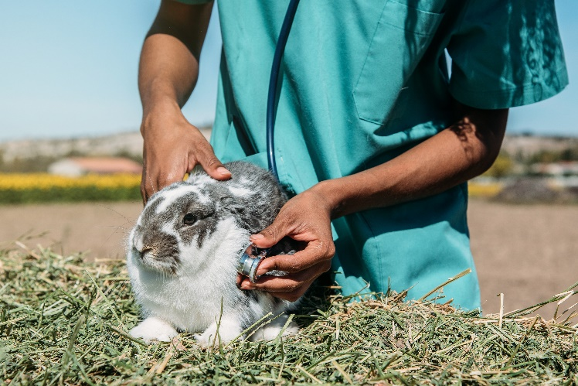
Veterinarians
They prevent, identify, and treat diseases, disorders, and injuries of pet, farm, and wildlife animals.
They work indoors and outdoors at farms, zoos, animal health companies, animal clinics, and government agencies.
They need an accredited graduate degree in veterinary medicine.

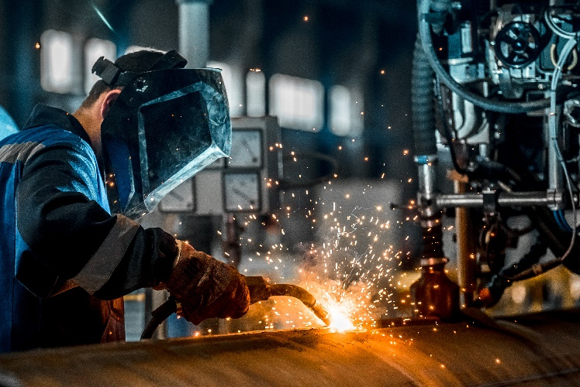
Welders
They join metal parts together using high heat to build and repair equipment and structures.
They work indoors and outdoors at agricultural equipment, food processing, mining, and oil and gas companies.
They need a high school diploma and often a welding certification.

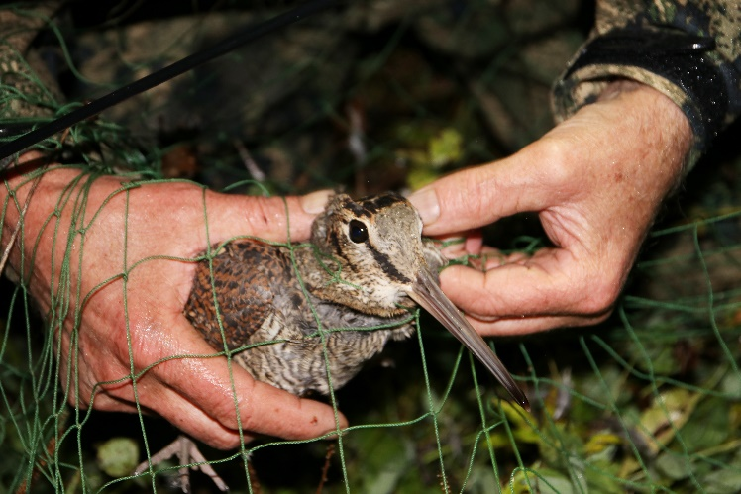
Wildlife Biologist/Ecologists
They study wild animals and habitats to improve the protection and management of these wild animals.
They work indoors and outdoors at government agencies, conservation organizations, and engineering firms.
They need a bachelor’s degree and often a graduate degree.

